**Protocol for measuring mitochondrial function and CORT from pilot *delicata* – by OC 10/03/2023**

**Good resources here:** [https://www.agilent.com/en/product/cell-analysis/how-to-run-an-assay](https://aus01.safelinks.protection.outlook.com/?url=https%3A%2F%2Fwww.agilent.com%2Fen%2Fproduct%2Fcell-analysis%2Fhow-to-run-an-assay&data=05%7C01%7COndi.Crino%40anu.edu.au%7C5470af607f9b43facb7608dac848f81e%7Ce37d725cab5c46249ae5f0533e486437%7C0%7C0%7C638042512986261880%7CUnknown%7CTWFpbGZsb3d8eyJWIjoiMC4wLjAwMDAiLCJQIjoiV2luMzIiLCJBTiI6Ik1haWwiLCJXVCI6Mn0%3D%7C3000%7C%7C%7C&sdata=IjUAxivN0CftgoQUcV42S%2BQQZ9JeiI91XYJKprwLafc%3D&reserved=0)

**Background:** High CORT treatment reduces body size in hatchling and juvenile skinks.

**Hypotheses:** We will test two mechanisms to explain differences in body size.

1) Treatment with CORT *in ovo* programs HPA axis such that lizards exposed to the high CORT treatment have higher levels of baseline CORT at hatching and as juveniles. For these effects to be programmatic, we should be able to detect them into adulthood.

2) Developmental CORT treatment reduces the efficiency of liver mitochondria. The liver has an important role in gluconeogenesis. Decreased efficiency of liver mitochondrial function would explain why lizards exposed to CORT *in ovo* hatch at a smaller body size.

These hypotheses are potentially related. For example, if developmental CORT treatment has programmatic effects on HPA axis and there is a correlation between baseline CORT and liver mitochondrial function, this would explain the continued effects of developmental treatment on body size (i.e., they grow slower and potentially achieve a smaller adult body size). However, if there are no effects of developmental treatment on adult baseline CORT, but there are effects on liver mitochondrial function (for example), this suggests that there are programmatic effects of developmental treatment on mitochondria, but that these effects are not being regulated indirectly through changes in the HPA axis.

**Project objectives:**

**1) Measure baseline CORT levels – priority**

**2) Measure mitochondrial function in liver tissue – priority**

**3) Measure body size and mass** – **priority;** we need a final body size measurement which will give us n= 4 measurements from hatching onward.

**4) Sex lizards** – **priority;** we need to sex all the lizards for analyses. Apparently, this can be done after they are euthanized, and tissues are removed.

**5) Dissect out brains –** This will not generate data for this project but will allow Pablo the opportunity to practice brain dissections for his project and to collect tissues to be used to optimize methods (non-mito measurements).

**Timeline:**

1. **Book Seahorse well in advance.**
2. **The day before the assay**
   1. The Seahorse temperature must be changed to 30°C the night before the assay. The incubator in the Seahorse room must also be changed to 30°C the night before the assay.
   2. Prepare PBS and mitochondria buffer stock solutions if needed.
   3. Hydrate Seahorse sensor cartridge the night before the assay (see below).
3. **The day of the assay**
   1. Prepare mitochondria stress chemicals prior to euthanizing animals. Keep on ice or in refrigerator before use.
   2. Prepare mitochondria buffer prior to euthanizing animals. Keep on ice or in refrigerator before use.
   3. After euthanizing animals, make sure the centrifuge has been turned on and is chilled to 4°C before processing tissue samples.
   4. Save aliquot of raw homogenate before centrifuging samples (see below).
   5. Save aliquot of processed homogenate after processing samples (see below).
   6. Run Seahorse assay
4. **After the assay**
   1. Bradford assay
   2. CORT assay

**Recipes**

1. **Phosphate buffered saline (PBS) - make before tissue collection**
   1. For 500 mL of 10X PBS: 8.9 g of Na2HPO4*2H20 (100mM) + 1.2 g of KH2PO4 (18mM) + 40g of NaCl (1.37M) + 1 g KCl (27mM).
   2. For 1 L of 1X PBS: 100 ml of 10x PBS + 900ml of ddH2O
2. **Mitochondria buffer stock solutions - make before assays if needed**
   1. Glucose (1.0 M solution) – To make 25 ml

Molecular weight of glucose (anhydrous) = 180.16 g/mol

Concentration = 1.0 mol/L * 180.16 g/mol

1M concentration = 180.16 g/L = 180.16 mg/mL

*To make 25mL:*

* + - 180.16 mg/mL * 25 mL = 4,504 mg = 4.50 g
    - Combine 4.50 g of glucose with 25 mL of ddH20
    - Aliquot in 500ul and store at -20C
  1. Sodium Pyruvate (100 mM solution) – To make 25 mL

Molecular weight of sodium pyruvate = 110.04 g/mol

Concentration = 1.0 mol/L * 110.04 g/mol

1M concentration = 110.04 g/L

1mM concentration = 0.11004 g/L

100mM concentration = 0.11004 g/L * 100 = 11.004 g/L = 11.004 mg/mL

*To make 25mL:*

* + - 11.004 mg/mL * 25 mL = 275.1 mg = 0.2751 g
    - Combine 0.2751 mg of sodium pyruvate with 25 mL of ddH20
    - Aliquot in 500ul and store at -20C
  1. L-glutamine (200 mM solution) – To make 25 mL

Molecular weight of sodium pyruvate = 146.14 g/mol

Concentration = 1.0 mol/L * 146.14 g/mol

1M concentration = 146.14 g/L

1mM concentration = 0.14614 g/L

200mM concentration = 0.14614 g/L * 200 = 29.228 g/L = 229.228 mg/mL

*To make 25mL:*

* + - 229.228 mg/mL * 25 mL = 5730.7 mg = 5.7307 g
    - Combine 5.7307 g of L-glutamine with 25 mL of ddH20
    - Aliquot in 500ul and store at –20C

1. **Mito stress chemicals**
   1. **Stocks – make day of assay**
      1. Oligomycin – add 630 µl of media buffer to stock tube for 100 µM stock concentration
      2. FCCP – add 720 µl of media buffer to stock tube for 100 µM stock concentration
      3. Rot/antimycin A – add 540 µl of media buffer to stock tube for 50 µM concentration
   2. **Diluted stocks for assays – make day of assay**
      1. Oligomycin – For final well concentration 1.5 uM
         1. 450 uL of stock to 2,550 ul of media buffer
      2. FCCP – To test 0.25, 0.5, and 1.0 uM
         1. 1.0 uM: Add 300 ul of stock solution to 2,700 ul of media buffer
         2. 0.5 uM: Add 1,500 ul of 1.0 uM solution to 1,500 ul of media buffer
         3. 0.25 uM: Add 1,500 ul of 0.5 uM solution to 1,500 ul of media buffer
      3. Rot/antimycin A – For final concentration of 0.5 uM
         1. Add 300 ul of stock solution to 2,700 of media buffer
2. **Mitochondria buffer – to make 10mL (enough for one plate); make day of assay**
   1. XF Base medium – 9.70 mL
   2. Glucose (1.0 M solution) – 100 µl
   3. Pyruvate (100 mM solution) – 100 µl
   4. L-glutamine (200 mM solution) – 100 µl

**Methods**

1. Body measurements, euthanasia, and tissue collection

1. Start a timer as soon as an enclosure is disturbed.
2. Inject animal with sodium pentobarbital (record time of injection)
3. Measure SVL, tail, and body mass
4. Euthanize lizard by decapitation
5. Trunk blood will be collected into heparinized microcapillary tubes. We will note the time as soon as the blood has been collected. The blood will be put into Eppendorf tubes and kept on ice until processing (see below). Ideally, we will collect ~100ul of blood.
6. If there is extra blood, we will measure hemoglobin (see below)
7. The head goes to Pablo who will follow his own protocol for dissection and processing.
8. The liver will be removed and processed (see below). We will record the time when the liver is removed.
9. Lizards will then be sexed by either palpitation or dissection to determine the presence or absence of hemipenes.

2. Blood processing (to obtain CORT for hormone assays)

1. Centrifuge blood at **7000 rpm for 7 minutes** to separate plasma from red blood cells.
2. Remove plasma, put in new Eppendorf tube, and store at -20°C. This plasma will be used to measure baseline CORT levels.

3. Liver processing – making homogenates and isolating cells (all this done on ice, cold temps, and using ice-cold buffers)

1. Remove whole liver from lizard.
2. Rinse with ice-cold phosphate-buffered saline (1X); does not have to be sterile.
3. Homogenize in Dounce homogenizer as follows:
4. Use assay buffer supplemented with glucose, l-glutamine, and sodium pyruvate
5. Rinse homogenizer with ice cold PBS 3x before use
6. Add liver and 1ml of ice-cold mitochondria buffer to homogenizer (keep Falcon tube of buffer on ice)
7. With homogenizer on ice, use three hand gentle hand passes to homogenize (upward motion more important than downward motion).
8. Transfer homogenate to clean Eppendorf tube and keep on ice
9. Centrifuge tubes at **750 x g, 4°C for 10 minutes**
10. **Save the supernatan**t into a clean Eppendorf tube (mitochondria are in the supernatant)
11. **Centrifuge at 10,000 x g, 4°C for 5 minutes**. Take off and dispose of supernatant (**mitochondria are now in pellet**)
12. Resuspend in 900 µl of mitochondria buffer using gentle up a down with pipette tip
13. Keep on wet ice until use in Seahorse assay

5. Measuring mitochondria function using the Seahorse

***The evening before the assay/day of tissue collection*** – hydrate the Seahorse XFe96 sensor cartridge

1. Add 200 µl of sterile water to each well on the calibrant plate
2. There must be no air bubbles. To dislodge air bubbles, gently raise and lower the sensor cartridge into the water in the calibrant plate several times.
3. Incubate the plate and cartridge overnight in a humidified incubator at 30°C (assay temperature) at atmospheric CO2.
4. Include a 50mL aliquot of the XF calibrant in the incubator

*Preparing mitochondria medium*

1. Prepare 10 mL of supplemented media (recipe above). The additions to base media are what is recommended for work with liver cells.
2. Incubate at 30°C (assay temperature) in a falcon tube.

*Preparing the tissue homogenate dilutions for Plate 1 of optimizations*

1. Starting dilution is whole liver in 900 ul
2. Need 3 * 100 ul to run samples in triplicate + 155 ul for Bradford assay (test); so need at least 600 ul in tube
3. Dilution 1: whole liver in 900 ul (Concentration 1 = x mg of liver / 900 ul of buffer)
4. Dilution 2: 300 ul of Dilution 1 + 300 ul of media buffer (1:2); Concentration 2 = 1/2
5. Dilution 3: 300 ul of Dilution 2 + 300 ul of media buffer (1:4); Concentration 3 = 1/4
6. Dilution 4: 300 ul of Dilution 3 + 300 ul of media buffer (1:8); Concentration 4 = 1/8

*Preparing the culture plate with tissue homogenates*

1. Add 100 µl of tissue suspension to each designated well in the PVL coated culture plate. This will be three wells (samples run in triplicate) so samples should be re-suspended at least 350 µl of media. Sample order will be recorded on 96 well data sheet.
2. Fill blank (background) wells with 100 µl of media. There should be plenty of these (e.g., n = 2 in each corner of plate)
3. Centrifuge plate **at 800 g for 3 minutes on a low brake centrifuge setting** (es:3). This sticks the cells to the bottom of the plate
4. Top up each well with 75 µl of media for a total volume of 175 µl

*Preparing compound* ***working*** *solutions – prepare solutions but do not load ports until getting to the JCSMR (volumes for each port listed here though)*

* Port A Oligomycin (final well concentration 1.0 µM)
  + 20 µl of working solution added to each port
* Port B FCCP (for all final well concentrations)
  + 22 µl of working solution added to each port
* Port C Rotenone/antimycin A (final well concentration 0.5 µM)
  + 25 µl of working solution to each port
* Port D: N/A

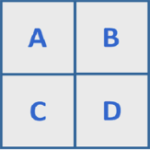

*Before leaving for the JCSMR*

1. Replace the water in the wells of the sensor cartridge with 200 µl of calibrant solution
2. Put the sensor cartridge back in the calibrant plate ensuring no air bubbles

*Loading working solutions into the ports of the sensor cartridge*

1. Cell culture microplate will have to be kept at 28°C in the JCSMR during calibration.
2. Load working solutions into ports at the JCSMR (to avoid walking with loaded cartridge between labs)
3. Use multi-channel pipette and reverse pipette to prevent air bubbles

*Running the assay*

1. Set up file template ahead of time
2. Place calibration plate with loaded sensor cartridge in instrument tray and click START. Calibration takes 15 – 30 minutes.
3. After calibration, load cell culture microplate and click I’m Ready.

6. Calculating protein content of each sample – Bradford assay

1. Testing two possible ranges of tissue concentrations (125 – 1500 ug/mL and 1-25 ug/mL) and two possible sampling points (raw tissue homogenate and processed tissues homogenates (used directly in Seahorse assay)).
2. Need 150ul of sample for low range and 5ul of sample for high range, so keep 200ul of raw homogenate in Eppendorf tube (will need to adjust concentration for this) and 200ul of processed sample
3. Samples can be kept in -20° until assayed
4. Assay methods
   1. Thaw frozen samples
   2. Vortex thoroughly before pipetting
   3. Warm reagent to room temperature before use
   4. Dilute one albumin standard (BSA) into mitochondrial buffer (needs to be the same diluent used in the samples, important because the buffer as phenol red in it). Dilutions are in Table 1 and depend on the tissue concentration (125 – 1500 ug/mL and 1-25 ul/mL)
   5. For range of 125 – 1500 ug/ml: pipette 5ul of sample into each well. Add 250 ul of Coomassie reagent and mix on plate shaker for 30 seconds. Incubate at room temperature for 10 minutes. Measure absorbance at 595 nm with plate reader. Subtract ‘blank’ wells and calculate protein values for each sample from standard curve
   6. For range of 1-25 ug/mL: pipette 150ul of sample into each well. Add 150ul of Coomassie reagent and mix on plate shaker for 30 seconds. Incubate at room temperature for 10 minutes. Measure absorbance at 595 nm with plate reader. Subtract ‘blank’ wells and calculate protein values for each sample from standard curve (four parameter or quadratic fit is best) 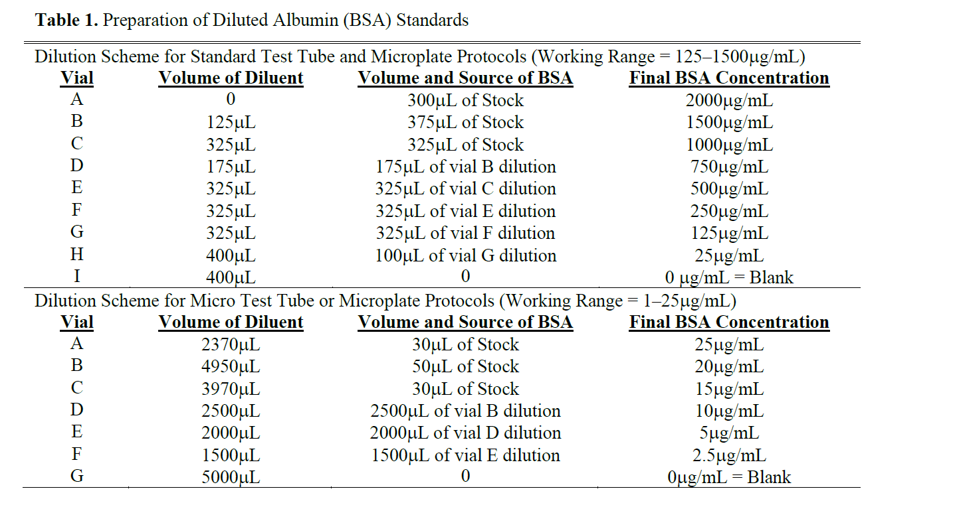

7. Measuring plasma CORT (EIAs)

1. Ideally CORT levels will be measured in triplicate. 50µl aliquots are required per replicate for assay. Therefore, 200 µl of diluted sample needs to be available. Baseline CORT levels are likely low and a dilution of 1:10 has been used in other species (e.g., *Zootoca vivipara*; Voituron et al. 2022). Following this, plasma samples will be diluted as 20 µl of plasma + 180 µl of assay buffer. (Dilutions will be optimized prior to assays using standard techniques. If a 1:10 dilution is too dilute OR if it is not possible to get at least 50 µl of whole blood (assuming a 50% hematocrit makes 25 µl of plasma), then samples can be run in duplicate (diluted to a volume of 150 µl with 15 µl plasma + 135 µl assay buffer).
2. Standard EIA methods will be followed.

Division of labor

* Dan – catching, measuring, and euthanizing lizards. Will collect trunk blood following decapitation.
* Dalton – initial blood processing. Will blow out capillary tubes in Eppendorf tubes.
* Pablo – will dissect out brains
* Ondi – will dissect out livers and make homogenates
* Kris – will keep track of time and morphometric data and confirm the sex of lizards following liver dissection